Melvin Vazquez-Andujar

3/7/2024

**Pokémon Card Game Simulator**

**Description of Program:**

This program is a simple simulator of the card game Pokémon which uses a multitude of classes to create and make this program. Inheritance and polymorphism is a big factor in how the classes connect with each other and work together to create a working card game that is similar to the card game. The parent class was Card since this game is built upon using cards and the child classes were Pokémon, Trainer, and Energy. That was the base foundation of the game and from there it was expanded by adding actual Pokémon card classes, trainer card classes, and energy card classes to be able to play. There is also a player class made so there is someone playing the game and checking for winner at the end of each player turn.

**How it Operates:**

This program works by using the player class to call upon the other classes part of the Pokémon game and to initialize variables inside player class. These variables will be used in tandem with the Trainer, Pokémon, and Energy card classes. In the player class there is a deck, bench, active Pokémon, discard field, hand, and prize pool all initialized to start up the game. This game is much simpler since only 4 Pokémon’s were created and the options are limited to attack, add to bench, play trainer, attach energy, and retreat. This game keeps running until one of the winning conditions is met by the player.

**Neat Things I added:**

One of the neat things I added to this Pokémon game is the option to retreat when the user doesn’t want his active Pokémon to take any more damage or if player wants to switch out Pokémon with another on his bench. Another neat thing I added is the use of the required energy that the Pokémon needs if he wants to make a successful attack.

**CODE OUTPUT**

***Start of Game:***

**Start of Player Turn:**

**Option 1 Attach Energy:**

**Option 2 Add To Bench:**

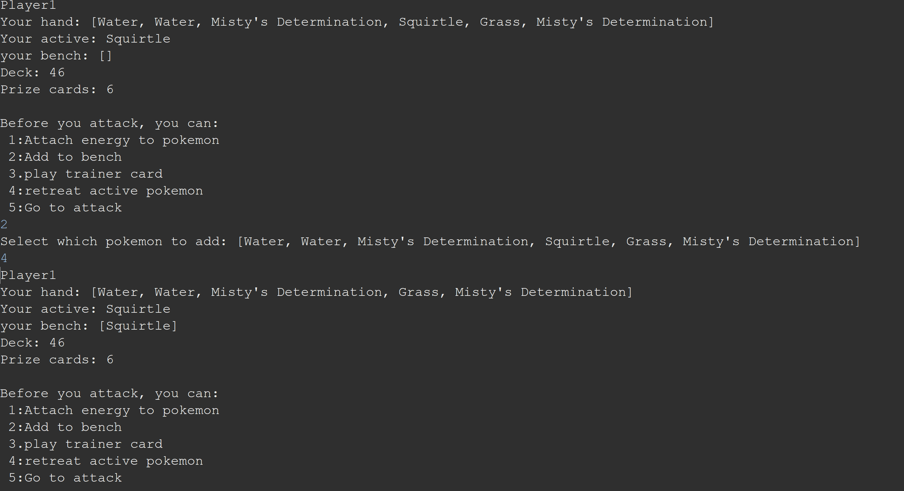

**Option 3 Play Trainer Card:**

**Option 4 Retreat (ONE OF THE NEAT THINGS I ADDED):**

**Option 5 Attack (ONE OF THE NEAT THINGS I ADDED):**

**Option 5 After attaching enough Energy:**

**Win condition 1: No pokemon in bench**

**Win condition 2: Opponent runs out of cards**

**Win condition 3 – Collecting all prize cards:**

